0.95 inch Full Color SPI OLED Display

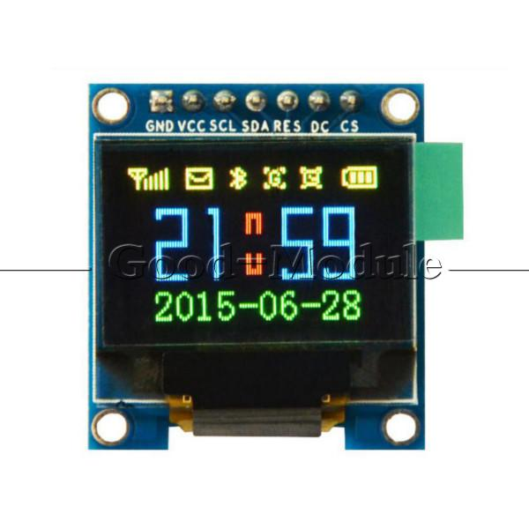

What is OLED?

OLED (Organic Light-Emitting Diode) is a self light-emitting technology composed of a thin, multi-layered organic film placed between an anode and cathode. In contrast to LCD technology, OLED does not require a backlight. OLED possesses high application potential for virtually all types of displays and is regarded as the ultimate technology for the next generation of flat-panel displays.

The use of OLED technology offers the following advantages for flat-panel displays?

1. A simplified manufacturing process compared to TFT-LCD

2. Self-emitting light, in contrast to the required backlight for TFT-LCD

3. High luminosity

4. Lightweight and thin

5. Capable of wide viewing angles

6. Low operating voltage and power consumption

7. Quick response

8. Wide range of operating temperatures (-40c to 85c)

Features:

100% Brand new and high quality.

Item name: 0.95 inch SPI OLED Display

Resolution:96*64

Color: 65536 Colors

Driver IC:SSD1331

Definition of SPI Connector:

1.GND-Gound

2.VCC-Positive Voltage

3.SCL-Clock Line

4.SDA-Data Line

5.RES-Reset

6.DC-Data/Demand

7.CS-Chip Select

This appears to work for me….

(Not a standard setup, changing pins should work too as long as they match)

SCL - Clock

SDA - Mosi/Data

Ucg Library setting:

Ucglib_SSD1331_18x96x64_UNIVISION_SWSPI ucg(/*sclk=*/ 10, /*data=*/ 9, /*cd=*/ 11 , /*cs=*/ 12, /*reset=*/ 13);

Ucglib FPS demo is pretty neat.

Adafruits SSD1331 library settings that worked for me:

// You can use any (4 or) 5 pins

#define sclk 10

#define mosi 9

#define cs 12

#define rst 13

#define dc 11